|  |
| --- |
| LinkBird Technologies |
| How to install Orion? |
| https://codecanyon.net/user/linkbirdtech |
|  |
|  |
|  |

|  |
| --- |
| Discover how easy it is to install Orion desktop onto your laptop or PC computer |

**Installation**

***System Requirements:***

* Operating system: Windows XP or Higher version
* Supported editions: 32-bit and 64-bit
* Preinstalled with the OS: .NET Framework 4.5

***Hardware requirements:***

* 1 GHz or faster processor
* 512 MB of RAM
* 850 MB of available hard disk space (x86)
* 2 GB hard drive (x64)

***Supported Operating System***

Windows 7 Service Pack 1, Windows Server 2008 R2 SP1, Windows Server 2008 Service Pack 2, Windows Vista Service Pack 2

* Windows Vista SP2 (x86 and x64)
* Windows 7 SP1 (x86 and x64)
* Windows Server 2008 R2 SP1 (x64)
* Windows Server 2008 SP2 (x86 and x64)

The following software packages must be installed on the operating system prior to installation of the software:

**Microsoft .NET Framework 4.5**

<https://www.microsoft.com/en-us/download/details.aspx?id=30653>

**Crystal Reports Redistributable**

SAP Crystal Reports 13.0 runtime (64-bit) (CRRuntime\_64bit\_13\_0\_12.msi)

<http://downloads.i-theses.com/?task=download_file&fileid=1015&no_html=1>

SAP Crystal Reports 13.0 runtime (32-bit) (CRRuntime\_32bit\_13\_0\_12.msi)

<https://jeff-net.com/software/CRRuntime_32bit_13_0_12.msi>

Orion supports 3 type database systems. Inside set-up folder contains three types of database supported setup file (Microsoft SQL Server, MySQL, SQLite). Pick any one according to your convenience.

**MySql Version**

This is the server base database system, you may need to install MySQL server (If not installed).

Go to **Setup > MySql Version** folder. Double click on **setup.exe** file.

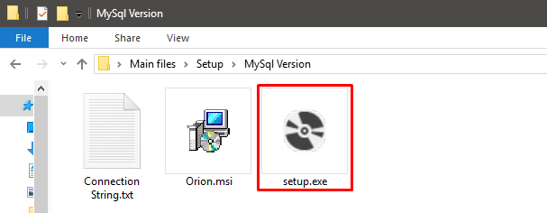

From the Setup Wizard window click on Next Button

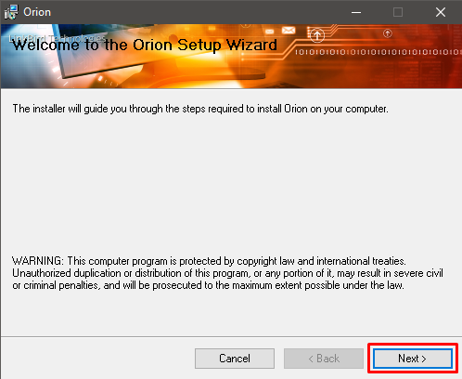

Do not install the software on C Drive because C Drive Read Only Drive. Install the software on another drive. Click Browse button.

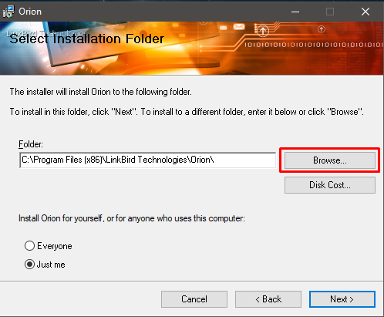

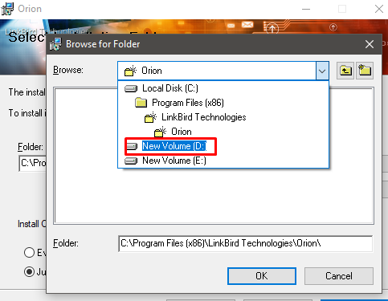

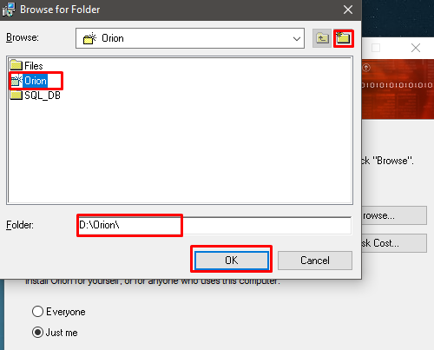

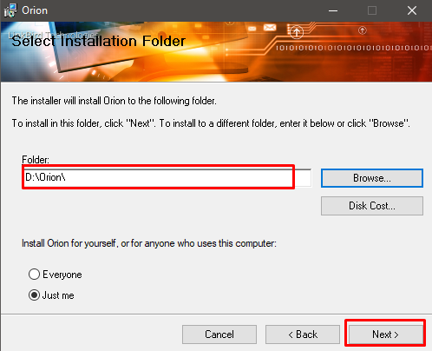

Now click on next button.

Within a short time the install will end and the icon of Orion will be created on the desktop. Now press the Close button.

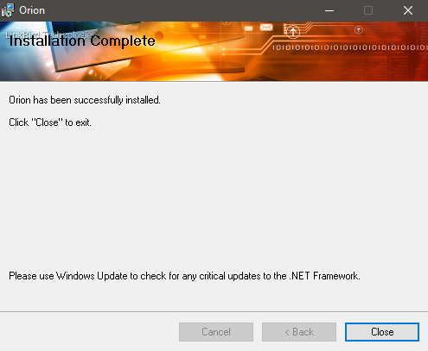

Double click on the Screenshot_57.png icon from the desktop. Enter your connection string into Orion Connection manager form. Click OK Button. A successful message dialog will be displayed then start Orion again.

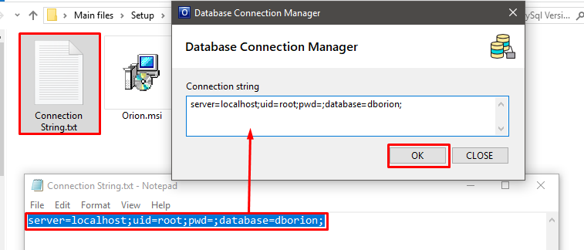

**SQL Server Version**

This is the server base database system, you may need to install MS SQL Server (If not installed).

Go to **Setup > SQL Server Version** folder. Double click on **setup.exe** file.

Follow the above mentioned methods.

Double click on the Screenshot_57.png icon from the desktop. Enter your connection string into Orion Connection manager form. Click OK Button. A successful message dialog will be displayed then start Orion again.

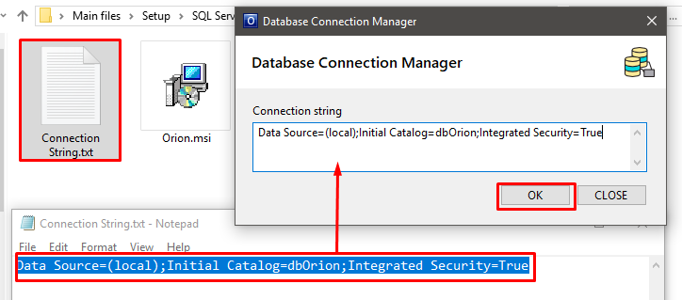

**SQLite Version**

Go to **Setup > SQLite Version** folder. Double click on **setup.exe** file.

Follow the above mentioned methods.

Double click on the Screenshot_57.png icon from the desktop. Enter your connection string into Orion Connection manager form. Click OK Button. A successful message dialog will be displayed then start Orion again.

